



Submitted By:

**Aditya Sharma**

**Kunal Patel**

**Heramba Panda**

**Sourav Gupta**

HERAMBA PANDA [118EI0372]

ADITYA SHARMA [118EI714]

SORAV GUPTA [118EI0359]

**EMBEDDED SYSETEM DESIGN LABORATORY**

**6TH Semester [2018-2022]**

**IoT Based Air Quality Monitoring System and**

**BlockchainSolution**

**Abstract**

* **Air pollution**:

Air pollution is occurred due to addition of peculiar proportion of substances in small particles, biological molecules along with severe gases, which may lead to short- and long-term disease, allergies and in worst cases mass death.

Types of pollutants:

1. Greenhouse gases (CO2, CH4,03, CO)
2. Acid rain (NOx, SO2, SO4)
3. Particular matter (PM2.5, PM10)

* **Air Quality Index:**

AQI is a method of representation of air quality in terms of its terminology, purity and color into a single index varying from 0 (meaning the best quality possible) to 500 (impossible to sustain in the environment)

There is different methodology to calculate the AQI (Calculation of AQI by CPCB and AQI Calculation Only Using PM2.5) along with different parameters like calculation of Dew points and speed of wind are to be considered as a severe factor while calculating AQI.

**Introduction of IoT to the project**

4 layers of IoT architecture would be used in the process.

1. **Application Layer:**

This layer acts as the user interface for the user who interacts with the android application, along with this shows the fetched data from lower layers which could be easily transmitted to represent the facility of showing the air quality level along with disease and allergies user has to be worried of by judging from his profile.

1. **Middle layer (Cloud server and Database):**

This layer is used for storing data and processing through Cloud Storage

and Cloud Database. The sensor data, either filtered or the otherwise, reaches cloud environments. The cloud environments are typically provisioned by a few public cloud providers such as Amazon AWS, Google Compute Engine, or IBM Cloud, or by a few in-house opensource cloud setup based on OpenStack, Open Nebula or so forth [3].

IB-AQMS are, typically, a few VM instances or dedicated servers of cloud providers.

Blockchain nodes are connected in a Peer-2-Peer distributed network fashion such that the nodes belong to various organizations. Each organization shall include multiple peer nodes where the copy of blocks are located. Each block contains the hashed values of the previous blocks and the transaction data along with the timestamp.

1. **Communication layer:**

This layer is there to make the connection between the hardware (i.e., sensing layer) and the software (i.e., to application layer through middleware layer) [6]. This uses the HTTP communication protocol to transfer the data from the hardware.

1. **Sensing layer:**

It allows us to connect the various sensors to a processor (in this case a raspberry pi). most of the sensors are analog type so there comes the need for an ADC which is ARPI6000 ADC module which is used to convert the analog value into the digital data. The raspberry pi allows us to connect our system to the internet via Wi-Fi or Ethernet. whereas to increase the communication options a SIM7000C module is also used to enable the communication through 3G/LTE or NB-IoT technologies[4].

The sensor unit includes the ten-gas sensor, one dust sensor, one wind speed sensor and one integrated sensor for temperature, humidity and dew point, and the Gas sensors such as CO2, CO, NO2, NO, NH3, H2S, SO2, CH4, O2, O3

**Power Supply Unit**

Power supply unit consists of a step-down circuit, a battery, a charge controller, and powerinput to the controller. Its specification is 12.8V/20Ah. The proposedhardware requires a different level of voltages 3.3V, 5V and 12V so for that purpose astep-down circuit is used [4].

**System Model**

This project aims to develop an IoT based application to deal with air pollution with the help of sensors such as MQ135, various air parameters are sensed andtransmitted [1].

* We used Raspberry Pi because it has built in Wi-Fi and allows us to connect us

system to the internet with an ease.

* The prototype connects with Wi-Fi and uploads all air parameters to centralized

server.

* Encryption of data was done in the server database using block-chain technology

and libraries like Hash library.

* To collect parameters many electro mechanical devices are used.
* These devices are heavy and not economical to install at many places.
* Periodical collection of data is difficult
* Still manual intervention is required for collecting and feeding data to central

servers.

* Data is not secured. It can be hacked or tempered
* Since its IOT based product all functional units are connected in a network.
* All things such as sensors base station,centralized server work together by means of

communication over network.

* Data collected from sensors gets uploaded to cloud servers instantly and it is

encrypted using block-chain technology.

* For authorities such as pollution control board, data is easily available and secure.
* They can draw conclusions and take actions instantly

**Hardware required**

1. Raspberry Pi
2. Memory Card – 32 GB or higher.
3. 1 MQ 135 sensor for CO2 measurement.
4. Resistors (1k, 2k ohm).
5. Bread board.
6. Jumper wires.

**Software required**

1. Knowledge of Block-Chain Technology.
2. Knowledge of Programming Language (Python).
3. App Development.
4. Cloud Server.
5. Cloud Database

**Implementation**

**Data flow diagram**

**Implementation of Blockchain**

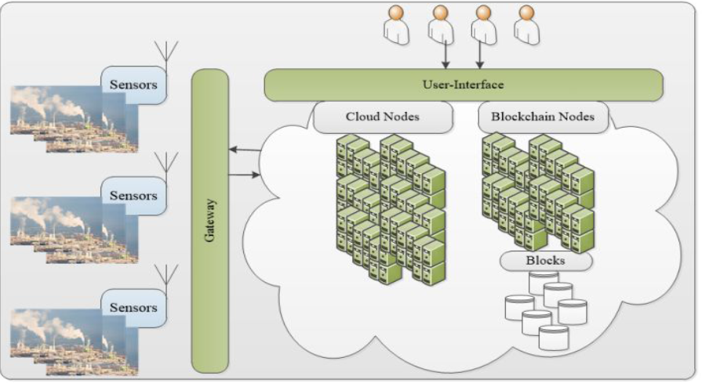

**Figure 1**: Blockchain Implementation

**Hardware connection**

We have used RASPBERRY PI Model 3B+ along with ARPI600 to convert data from analog to digital value. Since, raspberry Pi cannot take analog values as input [2][7][9].

**Steps for Hardware Connections**

1. First ARPI 600 Is installed on Raspberry Pio. All the 40 pins of Raspberry pi gets connected to 40 pins of ARPI 600
2. GND Of Sensor -> GND of Arpi600
3. VCC of MQ-135 sensor->3.3V of ARPI600
4. A0 of MQ-135 Sensor->T_A6 of ARPI600
5. D0 of MQ-135 sensor->P0 of ARPI600
6. FOR Setting I2C control Pins
7. We Connect A4 TO P_SCA and A5 TO P_SDA

**Schematic Diagram**

The steps mentioned above were followed and a hardware implementation of the module was obtained as shown in Figure 2.

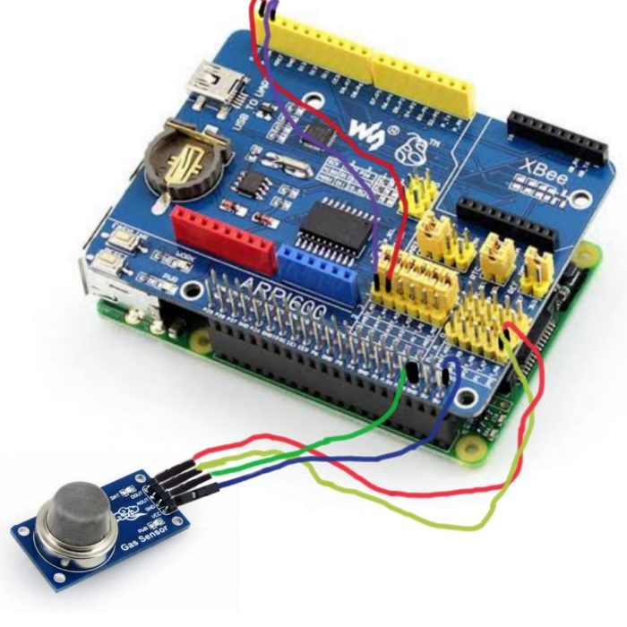

**Figure 2**: Hardware Implementation on Raspberry Pi

**Hardware implementation**

The connections mentioned above are made on a hardware assembly. Figure 3(a) and 3(b) below is a photograph of the implemented hardware before and after connecting it to the power supply.

|  |  |
| --- | --- |
|  |  |
| **Figure 3(a):** Hardware before giving power supply | **Figure 3(b):** Hardware before giving power supply |

**Software Implementation**

First Raspbian OS is set up in SD card using etcher. That SD card is then put into Raspberry pi

Raspberry pi was then installed and wifi connection was made using SSH.

Using Vnc viewer and knowing the IP address of the Raspberry pi we set up the raspberry pi OS in our desktop. Then the codes for getting data and uploading of the data was done in our pyrebase.

For running the codes Linux commands were used:

Chmod +x MQ_135-Gas_Sensors.c

Sudo MQ-135_Gas_Sesnors.c

**Result**

There have been several propositions in the past regarding an index which can be utilized forgetting a semi-quantitative or quantitative idea of air pollution. The index adapted currentlyin India is proposed by CPCB, and is given by sub-index [1],

where *i*= 1, 2, 3……..., n

where, *α* is the slope and *β* is the intercept at *X* = 0.

where,and B is the break-point concentration, C is the current concentration

and W is the weight assigned to the respective pollution parameters.

|  |
| --- |
|  |
|  |

**Future Enhancements**

1. It can be improved further by adding more sensors to existing system like dust particles sensors and others.
2. Interface GPS module to screen thecontamination at precise area and transfer on thewebsite page for the netizens.

**Conclusion**

1. Monitoring the environmental parameters especially with respect air plays very important role to ensure healthy environment for living beings. We have seen various hazards being caused at Delhi due to air pollution. There are many reasons for causing air pollution but knowing their concentration at various locations helps to take decisions on prevention measures.
2. The proposed application works on the principle of IOT, data read from sensor are processed by the processor then uploaded to database, these data are analysed and displayed to users, and user could fetch this information over phone or webserver and take proper action to prevent pollution.

**References**

1. AirQuality dataset, https://data.gov.in/catalog/air-quality-residential-areas-under-national-ambient-air-quality-monitoring-programme-few 2019.
2. AlMasri, EyhabDiabate, Ibrahim Jain, Richa Hoi Lam Lam, Ming Reddy Nathala, Swetha. (2018). A Serverless IoT Architecture for Smart Waste Management Systems. 179-180.10.1109/ICII.2018.00034.
3. Air Quality Indexing software, https://waqi.info/, 2019.
4. Benedict S., Revenue oriented air quality prediction microservices for smart cities, in IEEE 2017 International Conference on Advances in Computing, Communications and Informatics (ICACCI), Udupi, pp. 1-6, doi: 10.1109/ICACCI.2017.8125879.
5. Bharadwaj B, M. Kumudha, Gowri Chandra N and Chaithra G, "Automation of Smart waste management using IoT to support “Swachh Bharat Abhiyan” - a practical approach," 2017 2nd International Conference on Computing and Communications Technologies (ICCCT), Chennai, 2017, pp. 318-320. doi: 10.1109/ICCCT2.2017.7972300
6. Leo Breiman, Random Forests, in Machine Learning, Vol. 45, No.1, pp. 5-32, 2001.
7. Cai, C.-J., X. Zhang, K. Wang, Y. Zhang, L.-T. Wang, Q. Zhang, F.-K. Duan, K.-B. He, and S.-C. Yu, Incorporation of New Particle Formation and Early Growth treatments into WRF/Chem: Model Improvement, Evaluation, and Impacts of Anthropogenic Aerosols over East Asia, Atmospheric Environment, Vol.124, pp.262-284, 2016.
8. Giffinger R., Fertner C., Kramar H., Kalasek R., Pichler-Milanovic N., Meijers E., Smart cities: Ranking of ´ European medium-sized cities, http://www.smart-cities.eu/download/smart_cities_final_report. pdf, 2007.
9. Gubbi, J., Buyya, R., Marusic, S., &Palaniswami, M. (2013). Internet of Things (IoT): A vision, architectural elements, and future directions. Future Generation Computer Systems, 29(7), 1645-1660. doi:10.1016/j.future.2013.01.010.
10. P. Haribabu, S. R. Kassa, J. Nagaraju, R. Karthik, N. Shirisha and M. Anila, "Implementation of an smart waste management system using IoT," 2017 International Conference on Intelligent Sustainable Systems (ICISS), Palladam, 2017, pp. 1155-1156. doi: 10.1109/ISS1.2017.8389367
11. Hori, M., Ono, S., Miyashita, K., Kobayashi, S., Miyahara, H., Kita, T., . . . Yamaji, K. (2018). Learning System based on Decentralized Learning Model using Blockchain and SNS. Proceedings of the 10th International Conference on Computer Supported Education. doi:10.5220/0006666901830190.
12. A. Kadri, E. Yaacoub, M. Mushtaha, and A. Abu-Dayya, Wireless sensor network for real-time air pollution monitoring, in Proc. of IEEE Int. Conf. on Commn., Signal Proc. and their Appln, pp. 1 - 5, 2013.
13. Lake, D., Milito, R., Morrow, M., &Vargheese, R. (2014). Internet of Things: Architectural Framework for eHealth Security. Journal of ICT Standardization, 1(3), 301-328. doi:10.13052/jicts2245-800x.133.